**– Struktur File –**

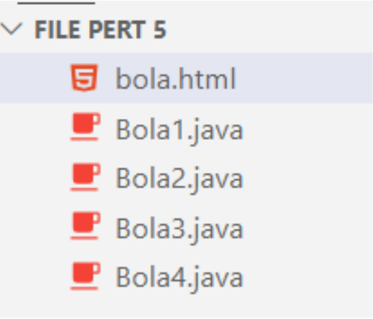

**– bola.html –**

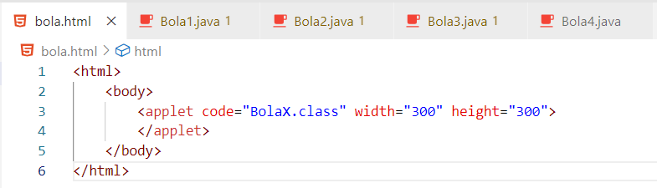

**– Bola1.java –**

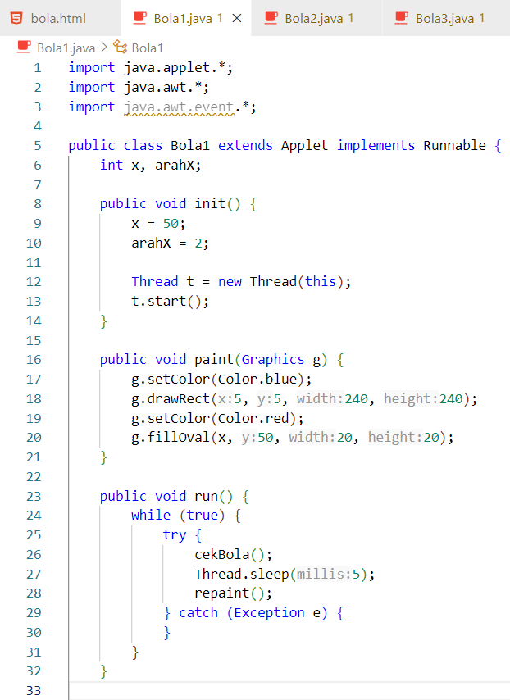

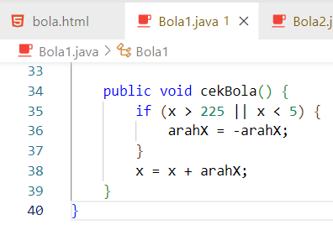

**– Bola2.java –**

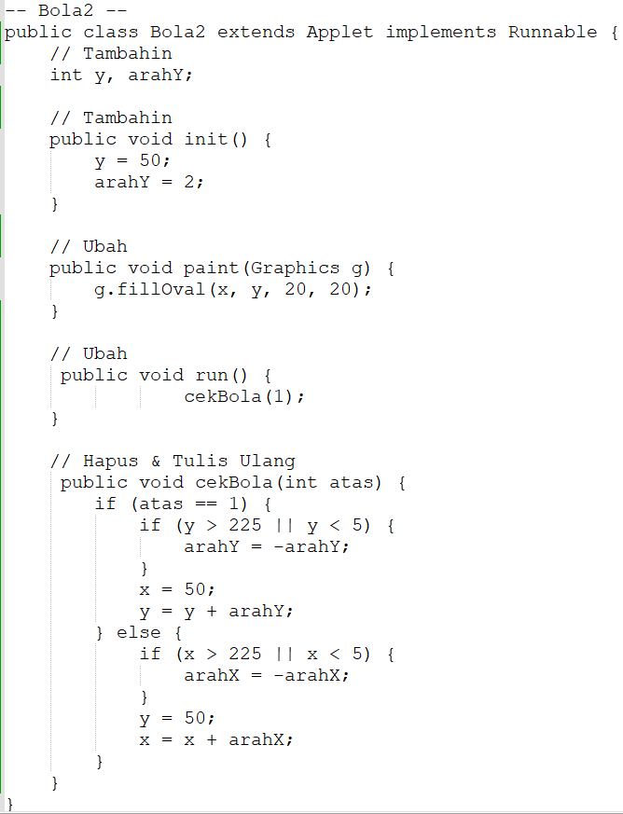

**– Bola3.java –**

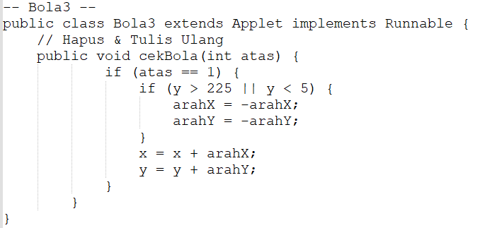

**– Bola4.java –**

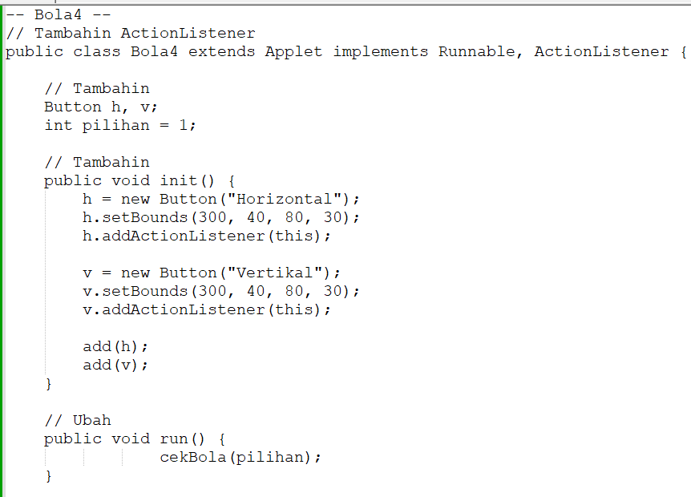

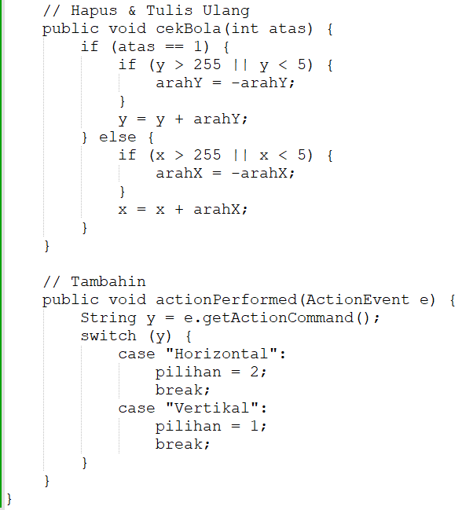

**– Cara Compile File Java –**

**javac NamaFile.java**

**– Cara Run Java Applet –**

**appletviewer bola.html**

**– Screenshotan –**

**Codingan**

**bola.html**

**Bola1.java**

**Bola2.java**

**Bola3.java**

**Bola4.java**

**– Format File –**

**Pert5_Act1_Anugerah Cahaya Utama_10120171**